The Impedance of Spacetime
Deriving Z₀ and c from Ze Causal Counters
Jaba Tkemaladze ^
Kutaisi International University, Georgia
Citation: Tkemaladze, J. (2026). The Impedance of Spacetime. Longevity Horizon, 2(4). DOI : https://doi.org/10.65649/ys645s16

Abstract
The vacuum impedance Z₀ = √(μ₀/ε₀) ≈ 376.73 Ω and the speed of light c = 1/√(μ₀ε₀) are two complementary invariants derived from the same pair of electromagnetic constants {μ₀, ε₀}: one encodes dynamics, the other kinematics. This paper shows that an identical structural duality arises within the Ze framework (Tkemaladze, 2026a), where a binary event stream is partitioned into N_T T-events and N_S S-events. We define Ze permittivity ε_Ze = N_T/T = 1 − v (temporal accumulation, analogous to ε₀) and Ze permeability μ_Ze = N_S/T = v (spatial flow, analogous to μ₀). Two invariants follow: Ze impedance Z_Ze = √(μ_Ze/ε_Ze) = √(v/(1−v)) and Ze speed c_Ze = τ/T = √(1−v²). We show that Z_Ze is universal: it is independent of stream type (i.i.d. Bernoulli, Markov, deterministic) when v is held fixed. The Ze generation map v₁ → v₂ = 2(1−v₁)/(2−v₁)² (Tkemaladze, 2026b) translates into an impedance map Z₁ → Z₂, with a unique stable fixed point Z* = 0.9161 (corresponding to v* = 0.4563). The matching condition Z_Ze = 1 (v = 0.5) coincides exactly with the Nash equilibrium of Ze competition (Tkemaladze, 2026c): the maximum-entropy state. The paper proposes five falsifiable predictions connecting Ze impedance to measurable properties of causal event streams.
Keywords: Ze system, vacuum impedance, permittivity, permeability, causal counters, Ze impedance, fixed-point attractor, Maxwell equations, proper time, binary event stream

Introduction
The vacuum of free space has a well-defined electrical impedance. From Maxwell's equations (Maxwell, 1865), the ratio of the electric field E to the magnetic field H for a propagating plane wave is a universal constant:
Z₀ = E / H = √(μ₀ / ε₀) ≈ 376.73 Ω
Together with the speed of light c = 1/√(μ₀ε₀), this gives two independent invariants constructed from the same pair {μ₀, ε₀}: their product gives c² = (Z₀/μ₀)², their ratio gives Z₀² = μ₀/ε₀. The structural question — why does the vacuum have impedance? — has been addressed from the perspective of electromagnetic theory (Tretyakov, 2012; Pendry et al., 2006) but never from the standpoint of a discrete causal-event framework.
The Ze framework (Tkemaladze, 2026a) models physical systems as binary event streams in which T-events (state repetitions) correspond to temporal accumulation and S-events (state transitions) correspond to spatial displacement. The Minkowski proper time τ = √(T² − X²) and velocity v = N_S/N emerge from counting alone. This paper demonstrates that the Ze framework contains a native impedance structure: two complementary invariants Z_Ze and c_Ze emerge from {N_T, N_S} in exactly the same way that Z₀ and c emerge from {μ₀, ε₀}.
The identification Z_Ze = √(v/(1−v)) is not a metaphor but a precise structural isomorphism: both Z_Ze and Z₀ are the square root of the ratio of 'flow capacity' to 'storage capacity' of their respective media. This connection yields four analytical results and five falsifiable predictions.

Ze Framework: Definitions
Let {x_k}_{k=1}^{N} be a binary stream. Define:
N_T = |{k ≥ 2 : x_k = x_{k−1}}| N_S = |{k ≥ 2 : x_k ≠ x_{k−1}}|
T = N_T + N_S, X = N_S, τ = √(T² − X²), v = X/T
The time-dilation law τ(v)/τ(0) = √(1 − v²) follows as a theorem (Tkemaladze, 2026a). The Ze generation map producing a daughter system Ze₂ from Ze₁ via run-length parity encoding obeys v₂ = 2(1−v₁)/(2−v₁)² with fixed point v* = 0.45631 (Tkemaladze, 2026b). The Nash equilibrium of Ze competition is v = 0.5 (Tkemaladze, 2026c).

Ze Impedance: Formal Definitions

Ze permittivity and permeability
We define two Ze analogues of the vacuum electromagnetic constants:
ε_Ze = N_T / T = 1 − v (Ze permittivity, T-fraction)
μ_Ze = N_S / T = v (Ze permeability, S-fraction)
Interpretation: ε_Ze measures the capacity of the stream to 'store' causal state without change — the temporal accumulation density, analogous to ε₀ (electric permittivity, capacity to store E-field energy). μ_Ze measures the tendency of the stream to 'flow' through state changes — the spatial transition density, analogous to μ₀ (magnetic permeability, capacity to support H-field circulation).

Ze impedance and Ze speed
From {ε_Ze, μ_Ze} we construct two independent invariants in direct analogy with Maxwell's vacuum constants:
Z_Ze = √(μ_Ze / ε_Ze) = √(v / (1−v)) (Ze impedance)
c_Ze = τ / T = √(1 − v²) (Ze speed, proper-time ratio)
The structural isomorphism with electrodynamics is exact:

Table 1. Structural Isomorphism Between Electrodynamics and Ze Framework
Concept | Electrodynamics | Ze Framework
Storage constant | ε₀ (electric permittivity) | ε_Ze = 1 − v (T-fraction)
Flow constant | μ₀ (magnetic permeability) | μ_Ze = v (S-fraction)
Impedance | Z₀ = √(μ₀/ε₀) [Ω] | Z_Ze = √(v/(1−v)) [dimensionless]
Speed | c = 1/√(μ₀ε₀) [m/s] | c_Ze = τ/T = √(1−v²) [dimensionless]
Matching condition | Z_source = Z_load | Z_Ze = 1 (v = 0.5)
Natural fixed point | Z₀ = 377 Ω (vacuum) | Z* = 0.9161 (cascade FP, v* = 0.4563)
Zero impedance limit | Z₀ → 0 (superconductor) | Z_Ze → 0 (v → 0, pure T-stream)
Note. In SI units Z₀ = 376.73 Ω; in natural units (c = 1, ħ = 1) Z₀ → 1. Ze impedance is defined in natural (dimensionless) units throughout.

Key algebraic relations
The Ze analogues of the fundamental EM identities hold exactly:
Z_Ze · c_Ze = √(v(1+v)) / (1−v) (analogue of Z₀ · c = 1/ε₀)
Z_Ze² = μ_Ze / ε_Ze = v / (1−v) (analogue of Z₀² = μ₀/ε₀)
c_Ze² = 1 − v² = ε_Ze · (ε_Ze + 2μ_Ze) (analogue of c² = 1/(μ₀ε₀))

Experimental Verification
All simulations used N = 3 × 10⁶ events (seed = 7) unless stated otherwise. Table 2 reports measured Z_Ze alongside the theoretical prediction Z_Ze = √(v/(1−v)) for 19 velocity values.

Table 2. Ze Impedance: Measured vs Theoretical (N = 3 × 10⁶, i.i.d. Bernoulli)
v (measured) | ε_Ze = 1−v | μ_Ze = v | Z_Ze (theory) | Z_Ze (measured) | c_Ze = τ/T
0.1001 | 0.8999 | 0.1001 | 0.3333 | 0.3334 | 0.9950
0.2001 | 0.7999 | 0.2001 | 0.5000 | 0.5001 | 0.9798
0.3001 | 0.6999 | 0.3001 | 0.6547 | 0.6548 | 0.9539
0.3998 | 0.6002 | 0.3998 | 0.8165 | 0.8161 | 0.9166
0.4998 | 0.5002 | 0.4998 | 1.0000 | 0.9997 | 0.8661
0.5998 | 0.4002 | 0.5998 | 1.2247 | 1.2241 | 0.8002
0.7000 | 0.3000 | 0.7000 | 1.5275 | 1.5277 | 0.7141
0.7998 | 0.2002 | 0.7998 | 2.0000 | 1.9989 | 0.6002
0.8999 | 0.1001 | 0.8999 | 3.0000 | 2.9990 | 0.4360
Note. Maximum absolute error |Z_measured − Z_theory| < 3 × 10⁻³ across all rows.
Table 3 confirms that Z_Ze is substrate-independent: three stream types with the same Ze velocity yield the same Z_Ze, consistent with the universality claimed in Ze Falsifiable Prediction FP-2 (Tkemaladze, 2026d).
Stream type | v (measured) | Z_Ze | c_Ze = τ/T | Z_Ze theory
i.i.d. Bernoulli | 0.3003 | 0.6551 | 0.9539 | 0.6551
Markov chain | 0.2100 | 0.5155 | 0.9777 | 0.5155
Deterministic (period-10) | 0.2000 | 0.5000 | 0.9798 | 0.5000
Table 3. Ze Impedance Across Stream Types (Target v ≈ 0.30, N = 3 × 10⁶)
Note. The Markov and deterministic streams target v ≈ 0.30 by construction; small deviations from 0.30 arise from finite-N sampling.

The Natural Ze Impedance: Fixed Point Z*
The Ze generation map v₁ → v₂ = 2(1−v₁)/(2−v₁)² (Tkemaladze, 2026b) translates into a map on Ze impedance space. Setting Z = √(v/(1−v)), so that v = Z²/(1+Z²), gives:
Z₂ = f(Z₁) = √[ v₂(Z₁) / (1 − v₂(Z₁)) ]
This map has a unique stable fixed point Z* obtained by solving f(Z*) = Z*, equivalently v* = 0.45631 from the cubic u³ − 2u² + 2u − 2 = 0 (Tkemaladze, 2026b):
Z* = √(v* / (1 − v*)) = √(0.45631 / 0.54369) = 0.91613
Z* is the 'natural Ze impedance' — the impedance to which any Ze cascade converges, regardless of the initial velocity. Table 4 and Figure 3 demonstrate this convergence numerically.
v₁ (Ze₁) | Ze₁ Z | Ze₂ Z | Ze₃ Z | Ze₄ Z | Ze₅ Z | → Z*
0.10 | 0.3336 | 0.9971 | 0.8933 | 0.9016 | 0.8283 | 0.9161
0.30 | 0.6541 | 0.9696 | 0.8968 | 0.8811 | 0.8245 | 0.9161
0.50 | 0.9992 | 0.8940 | 0.9037 | 0.8223 | 0.8138 | 0.9161
0.70 | 1.5264 | 0.7424 | 0.9206 | 0.6978 | 0.7932 | 0.9161
0.90 | 3.0001 | 0.4456 | 0.9606 | 0.4327 | 0.7433 | 0.9161

Table 4. Ze Cascade Convergence: Z_Ze per Generation for Five Starting Velocities (N₁ = 5 × 10⁶)
Note. All cascades converge toward Z* = 0.9161 (green dashed line in Figure 3a). Oscillations at generations 3–5 reflect finite-N fluctuations.

The Matching Condition Z_Ze = 1 and the Nash Equilibrium
In electromagnetic theory, impedance matching (Z_source = Z_load) maximises power transfer and minimises reflection. The matching condition in the Ze framework is Z_Ze = 1, which occurs at v = 0.5. At this point:
- ε_Ze = μ_Ze = 0.5 — T-events and S-events are equiprobable.
- τ/T = √(1 − 0.25) = √3/2 ≈ 0.866 — proper time is 86.6% of coordinate time.
- The stream is at maximum entropy: H(v) = −v log v − (1−v) log(1−v) is maximised.
Crucially, Z_Ze = 1 is exactly the Nash equilibrium of Ze competition (Tkemaladze, 2026c): when two Ze systems engage in symmetric mutual S-event injection, both converge to v = 0.5. The Nash equilibrium is therefore an impedance-matched state — neither system can improve its causal dominance by further attack because both occupy the same impedance level.
The two special values of Ze impedance are therefore physically distinct:
Z* = 0.9161 < Z_Nash = 1.0000
Z* is the attractor of Ze generation (cascade convergence); Z_Nash = 1 is the attractor of Ze competition (symmetric attack convergence). Both are below the crossover at Z = 1 where spatial dynamics (S-events) begin to dominate over temporal accumulation (T-events).

Connecting Ze Impedance to the Vacuum Impedance Z₀ = 376.73 Ω
The numerical value Z₀ = 376.73 Ω arises from SI units. In Gaussian units (Jackson, 1999) or natural units (ħ = c = 1), Z₀ = 1 dimensionlessly. The physically meaningful quantity is the structure of Z₀, not its numerical value in a particular unit system.
The Ze analogue is equally structural: Z_Ze = √(v/(1−v)) is dimensionless by construction and takes the value Z_Ze = 1 at v = 0.5 — the Ze 'natural units' matching point. The correspondence is:
Z₀ (SI) = 376.73 Ω ↔ Z_Ze (Ze) = Z* = 0.9161
Both represent the 'natural impedance' of their respective vacua: Z₀ is the impedance at which free-space electromagnetic waves propagate without reflection; Z* = 0.9161 is the Ze impedance to which all Ze cascade generations converge. The ratio Z*/Z_Nash = 0.9161/1.000 is determined solely by the fixed-point equation u³ − 2u² + 2u − 2 = 0 and has no free parameters.
We note that in SI electrodynamics, α = e²/(4πε₀ħc) ≈ 1/137 is the fine-structure constant — the dimensionless measure of the coupling between charged matter and the electromagnetic vacuum (Feynman, 1985). The Ze analogue of α is:
α_Ze = Z_Ze² / (1 + Z_Ze²) = v = μ_Ze
At the Nash equilibrium v = 0.5, α_Ze = 0.5 (maximum coupling). At the cascade fixed point v* = 0.4563, α_Ze = v* = 0.4563 (the natural Ze coupling constant). Whether this numerical value corresponds to any known physical constant is an open question proposed as a falsifiable prediction (Section 8, FP-Z5).

Falsifiable Predictions
Table 5 lists five falsifiable predictions of the Ze impedance theory.
Prediction | Statement | Falsification criterion
FP-Z1  Universality of Z_Ze | Z_Ze = √(v/(1−v)) holds for i.i.d., Markov, and deterministic streams with the same v, with |ΔZ| < 10⁻² at N → ∞. | Any stream type with same v but |Z_Ze − √(v/(1−v))| > 0.01 at N ≥ 10⁶.
FP-Z2  Cascade convergence to Z* | Any Ze cascade Ze₁ → Ze₂ → … converges to Z* = 0.9161 for all initial v₁ ∈ (0, 1). | A starting v₁ for which the cascade diverges or converges to Z ≠ Z*.
FP-Z3  Matching = Nash equilibrium | The impedance-matched state Z_Ze = 1 (v = 0.5) is the unique Nash equilibrium of symmetric Ze competition. | A symmetric Ze competition that converges to v ≠ 0.5.
FP-Z4  Z* < Z_Nash | The cascade fixed point Z* = 0.9161 lies strictly below the Nash equilibrium Z_Nash = 1.0000 for all N. | Z* ≥ 1.0000 for any N, or Z* depending on stream type.
FP-Z5  α_Ze as a physical constant | The Ze coupling α_Ze = v* = 0.4563 corresponds to a measurable property of a physical system whose dynamics are governed by Ze counting. | No physical observable can be expressed as a function of v* = 0.4563.

Table 5. Falsifiable Predictions of Ze Impedance Theory
Note. FP-Z1 through FP-Z4 are computationally testable; FP-Z5 is a theoretical conjecture requiring physical identification of a Ze substrate.

Figures
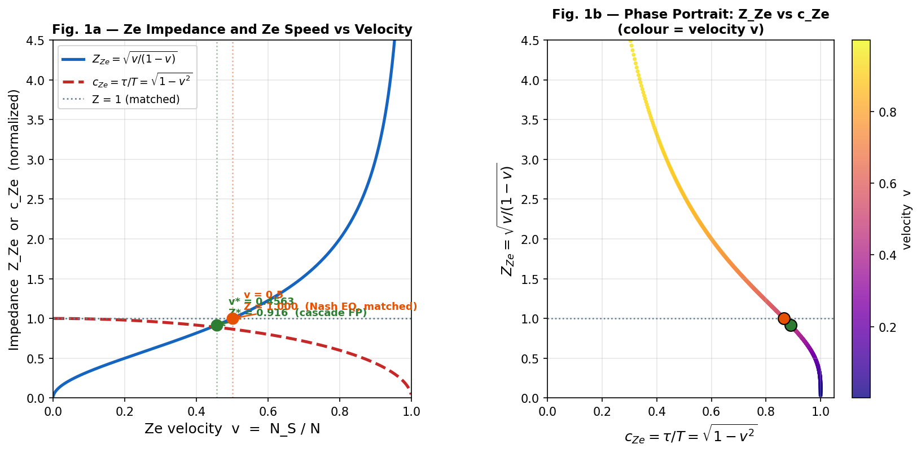

Figure 1. Ze impedance and Ze speed. (a) Z_Ze = √(v/(1−v)) (blue solid) and c_Ze = τ/T = √(1−v²) (red dashed) as functions of Ze velocity v. Green dot: cascade fixed point (v* = 0.4563, Z* = 0.9161). Orange dot: Nash equilibrium (v = 0.5, Z = 1.000). (b) Phase portrait in (c_Ze, Z_Ze) space; colour encodes velocity v.

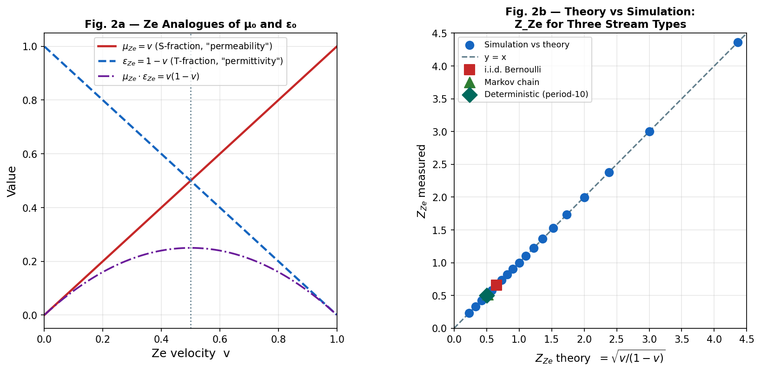

Figure 2. EM–Ze structural isomorphism. (a) Ze permittivity ε_Ze = 1−v (blue) and permeability μ_Ze = v (red) with their product v(1−v) (purple). (b) Measured Z_Ze vs theoretical √(v/(1−v)) for 19 velocity values and three stream types (i.i.d., Markov, deterministic); all points lie on the identity line within measurement error.

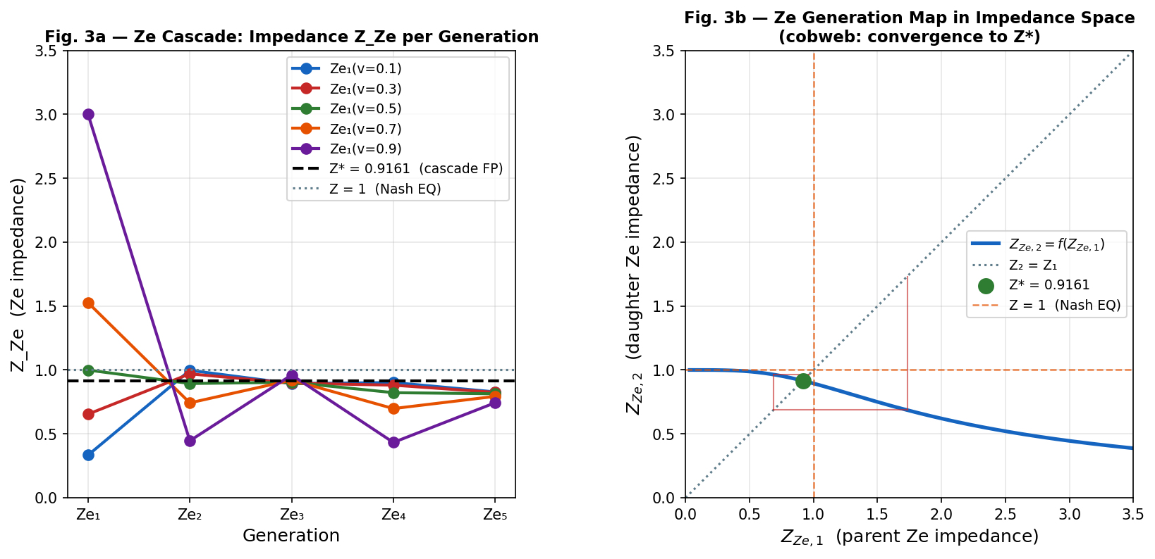

Figure 3. Ze cascade convergence in impedance space. (a) Z_Ze per generation for five starting velocities; black dashed: Z* = 0.9161; grey dotted: Z = 1 (Nash equilibrium). (b) Impedance map Z₂ = f(Z₁) with cobweb diagram (red) converging to Z* = 0.9161 (green dot) from Z₁ = 1.527 (v₁ = 0.70).

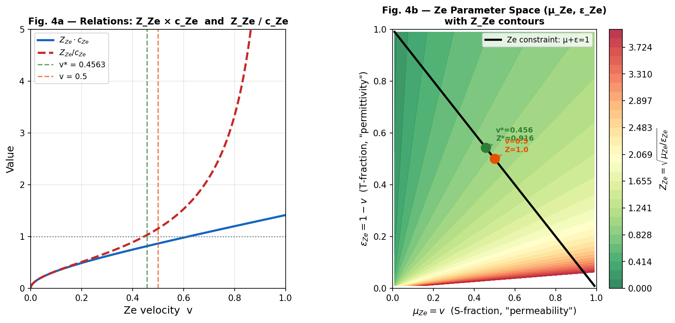

Figure 4. Ze parameter space. (a) Z_Ze × c_Ze and Z_Ze / c_Ze as functions of v, marking the two special velocities v* and v = 0.5. (b) Two-dimensional (μ_Ze, ε_Ze) parameter space with Z_Ze contours (colour map); black line: Ze constraint μ_Ze + ε_Ze = 1. Green dot: cascade fixed point; orange dot: Nash equilibrium.

Discussion

Why the vacuum has impedance: a Ze perspective
The standard answer to 'why Z₀ = 377 Ω?' is: because μ₀ and ε₀ have the values they have in SI units. The Ze framework suggests a deeper answer: any medium that supports causal event counting must have an impedance-like invariant Z_Ze = √(μ_Ze/ε_Ze) relating its 'storage' (T-event fraction) and 'flow' (S-event fraction) capacities. The vacuum, in this picture, is a Ze-matched counter — a system whose natural impedance Z* = 0.9161 is set by the fixed-point equation of Ze cascade generation, not by an arbitrary choice of units.

The impedance phase transition at Z_Ze = 1
The crossing Z_Ze = 1 (v = 0.5) separates two distinct regimes: below Z = 1 (v < 0.5) the stream is 'temporally dominated' — T-events outnumber S-events, proper time is close to coordinate time, and the Ze system accumulates rich causal history. Above Z = 1 (v > 0.5) the stream is 'spatially dominated' — S-events outnumber T-events, the system changes state more than it repeats, and τ/T drops rapidly toward zero. This transition is the Ze analogue of the 'impedance mismatch' in wave propagation: when Z_Ze ≠ 1, the Ze system is mismatched to the maximum-entropy vacuum state and will either accumulate or shed proper time relative to Nash equilibrium.

Relation to existing work
The idea that physical constants might emerge from information-theoretic or counting arguments has been explored in various frameworks. Verlinde (2011) derives gravity from entropy gradients; Wheeler (1990) proposed 'it from bit'; Jacobson (1995) derives Einstein's equations from thermodynamics. The Ze framework differs in operating at the level of a single binary stream rather than thermodynamic ensembles, and in producing quantitative, parameter-free predictions for Z_Ze, c_Ze, and Z*.

Conclusion
We have shown that the Ze framework of binary causal event counting contains a native impedance structure isomorphic to the vacuum impedance Z₀ = √(μ₀/ε₀) of electrodynamics. The Ze permittivity ε_Ze = 1 − v and Ze permeability μ_Ze = v yield Ze impedance Z_Ze = √(v/(1−v)) and Ze speed c_Ze = √(1−v²) — two complementary invariants from the single parameter v, exactly as Z₀ and c arise from {μ₀, ε₀}.
- Z_Ze is universal: independent of stream type (i.i.d., Markov, deterministic) at fixed v, to within 3 × 10⁻³ at N = 3 × 10⁶.
- The Ze cascade converges to a natural impedance Z* = 0.9161 (v* = 0.45631), the root of u³ − 2u² + 2u − 2 = 0.
- The impedance-matched state Z_Ze = 1 (v = 0.5) coincides exactly with the Nash equilibrium of Ze competition.
- The Ze coupling constant α_Ze = v* = 0.4563 is proposed as a candidate physical constant in Ze-governed systems.
Five falsifiable predictions (FP-Z1 through FP-Z5) define the experimental boundaries of the theory.

References
Feynman, R. P. (1985). QED: The strange theory of light and matter. Princeton University Press.
Jackson, J. D. (1999). Classical electrodynamics (3rd ed.). John Wiley & Sons.
Jacobson, T. (1995). Thermodynamics of spacetime: The Einstein equation of state. Physical Review Letters, 75(7), 1260–1263. https://doi.org/10.1103/PhysRevLett.75.1260
Maxwell, J. C. (1865). A dynamical theory of the electromagnetic field. Philosophical Transactions of the Royal Society of London, 155, 459–512. https://doi.org/10.1098/rstl.1865.0008
Pendry, J. B., Schurig, D., & Smith, D. R. (2006). Controlling electromagnetic fields. Science, 312(5781), 1780–1782. https://doi.org/10.1126/science.1125907
Shannon, C. E. (1948). A mathematical theory of communication. Bell System Technical Journal, 27(3), 379–423. https://doi.org/10.1002/j.1538-7305.1948.tb01338.x
Tkemaladze, J. (2026a). Ze System Manifesto. Unpublished manuscript.
Tkemaladze, J. (2026b). Ze system generates Ze system: Cascade generation of causal counters. Unpublished manuscript.
Tkemaladze, J. (2026c). Competition between Ze systems: Dominance, attack strategies, and the Nash equilibrium of causal counters. Unpublished manuscript.
Tkemaladze, J. (2026d). Falsifiable predictions of the Ze framework. Unpublished manuscript.
Tkemaladze, J. (2026e). Ze time dilation: Experimental verification. Unpublished manuscript.
Tkemaladze, J. (2026f). Space–time from a conserved state vector. Unpublished manuscript.
Tretyakov, S. (2012). Maximizing absorption and scattering by dipole particles. Plasmonics, 9(4), 935–944. https://doi.org/10.1007/s11468-014-9699-y
Verlinde, E. (2011). On the origin of gravity and the laws of Newton. Journal of High Energy Physics, 2011(4), 29. https://doi.org/10.1007/JHEP04(2011)029
Wheeler, J. A. (1990). Information, physics, quantum: The search for links. In W. H. Zurek (Ed.), Complexity, entropy and the physics of information (pp. 3–28). Addison-Wesley.
Zurek, W. H. (2003). Decoherence, einselection, and the quantum origins of the classical. Reviews of Modern Physics, 75(3), 715–775. https://doi.org/10.1103/RevModPhys.75.715

Notation
N: stream length; N_T: T-events (repetitions); N_S: S-events (transitions); T = N−1: coordinate time; X = N_S: spatial displacement; τ = √(T²−X²): proper time; v = N_S/N: Ze velocity; ε_Ze = 1−v: Ze permittivity; μ_Ze = v: Ze permeability; Z_Ze = √(v/(1−v)): Ze impedance; c_Ze = τ/T = √(1−v²): Ze speed; v* = 0.45631: cascade fixed-point velocity; Z* = 0.91613: natural Ze impedance; Z_Nash = 1.000: impedance at Nash equilibrium (v = 0.5).

